Testing BATO process

AC-02.00.01.02

Account Management

\*\*\*\*\*No Image Exist.jpg- No image exist\*\*\*\*\*

AC-02.00.02.01

Account Management

\*\*\*\*\*No Image Exist.jpg- No image exist\*\*\*\*\*

AC-02.00.03.01

Account Management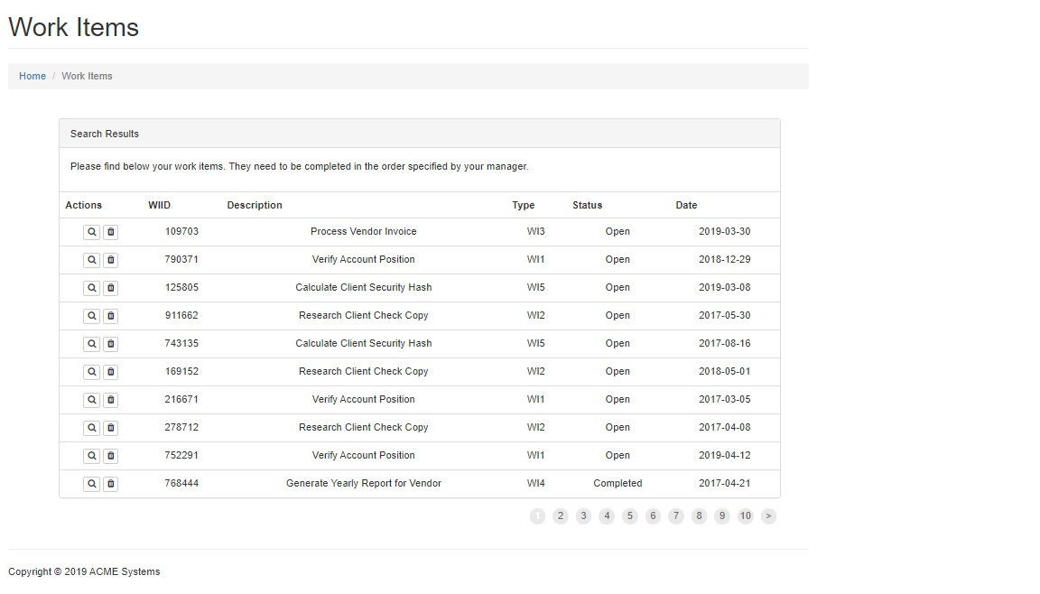

AC-02.00.04.01

Account Management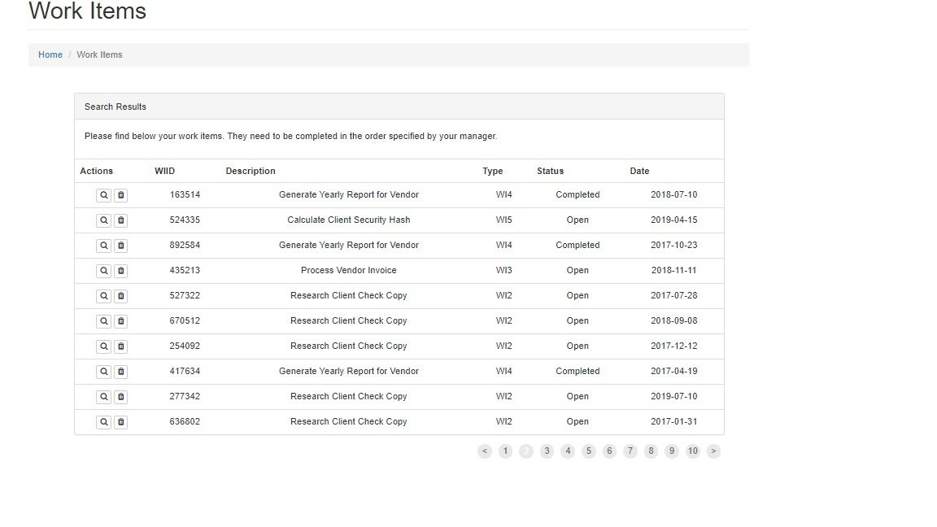

AC-02.00.04.02

Account Management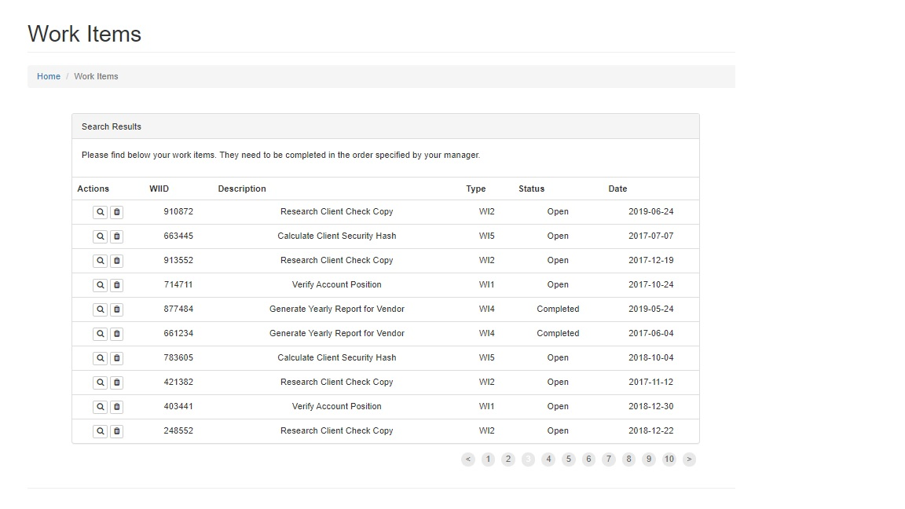

AC-02.00.04.03

Account Management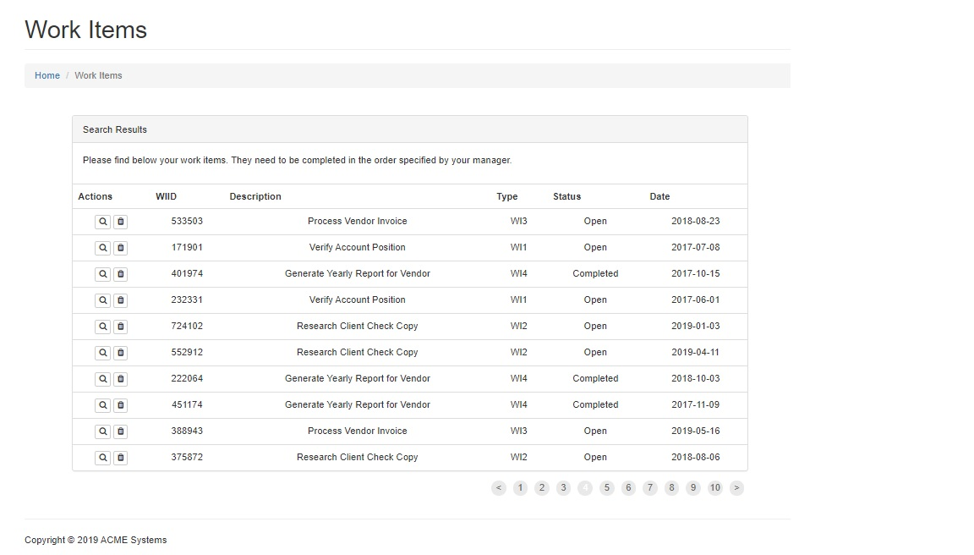

AC-02.00.05.02

Account Management

\*\*\*\*\*No Image Exist.jpg- No image exist\*\*\*\*\*

AC-02.00.07.01

Account Management

\*\*\*\*\*No Image Exist.jpg- No image exist\*\*\*\*\*

AC-02.03.02.01

Disable Inactive Accounts

\*\*\*\*\*No Image Exist.jpg- No image exist\*\*\*\*\*

AC-02.04.01.01

Automated Audit Actions